Training Information:
- Log in to the RDCRN (https://members.rarediseasesnetwork.org/home/) as detailed here: https://rdcrn.atlassian.net/wiki/spaces/RPD/pages/2097186/RDCRN+Login+Process.

- Click on the “Consortia pages” tab to select your consortium.
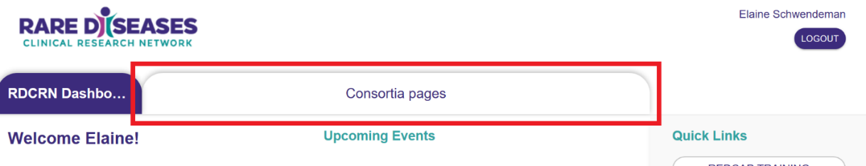

- Within your consortium’s page, click on the Protocols link.
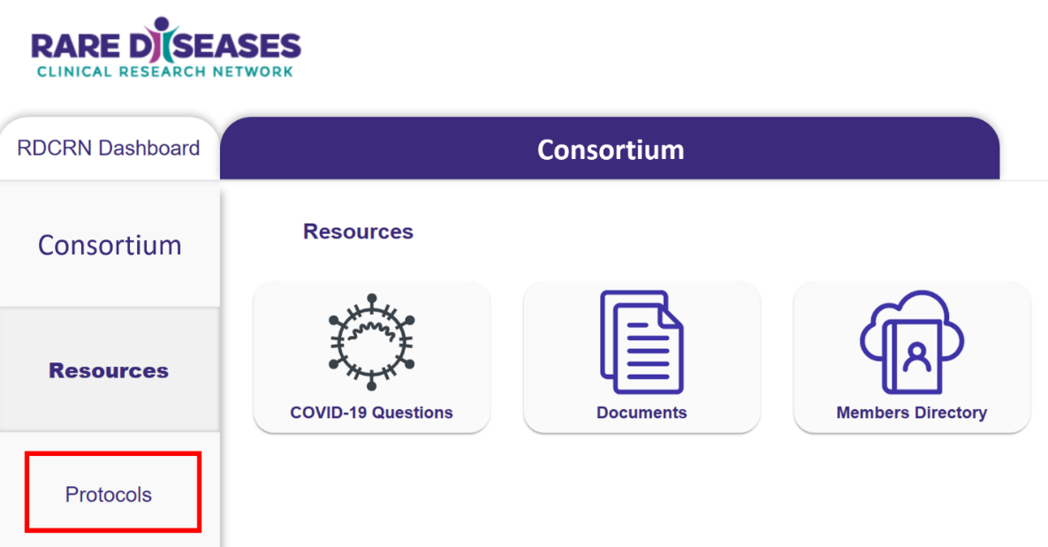

- From the Protocols page, click on the appropriate protocol number for access to training & the REDCap database.
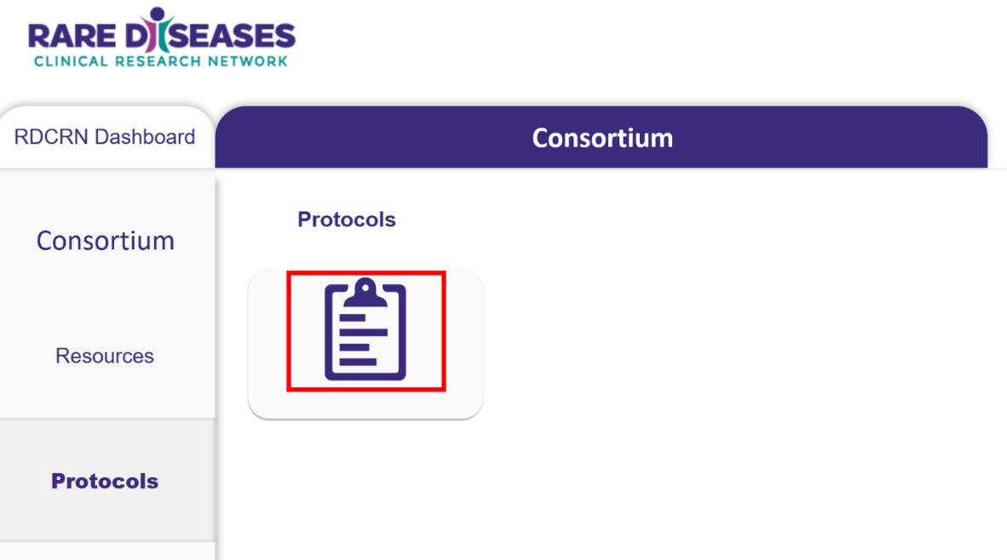

- Select the Database Training button to access the protocol training materials.
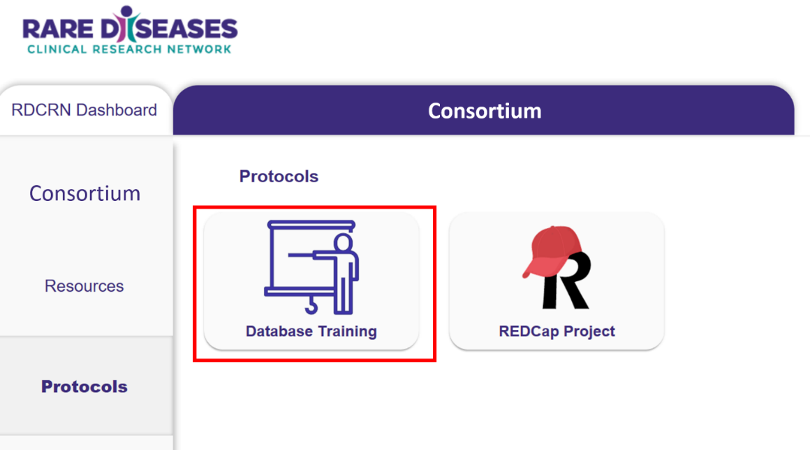

- Click the Video link to watch the recorded database training and click on the REDCap Database Training Documentation to certify your training.
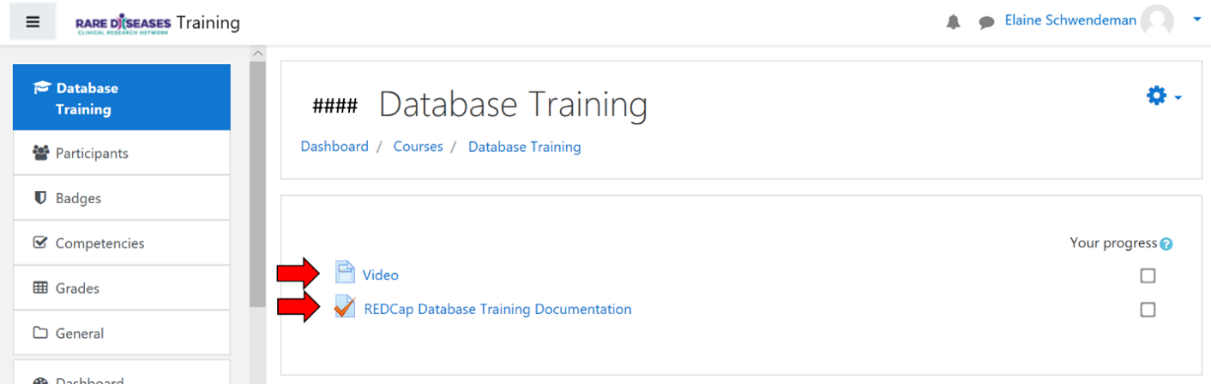

- Complete the quiz to attest that you have viewed either the live training demonstration or the recording.
