Training Information:
- Log in to the RDCRN (https://members.rarediseasesnetwork.org/home/) as detailed here: https://rdcrn.atlassian.net/wiki/spaces/RPD/pages/2097186/RDCRN+Login+Process.

- Click on the “Consortia pages” tab to select your consortium.
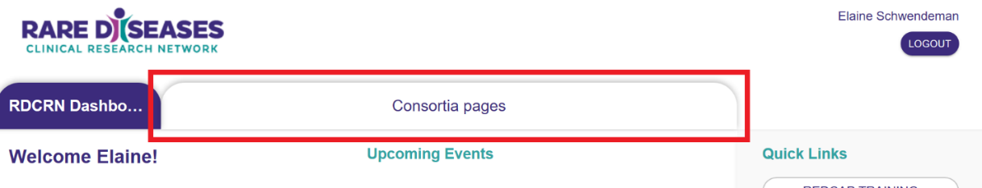

- Within your consortium’s page, click on the Protocols link.
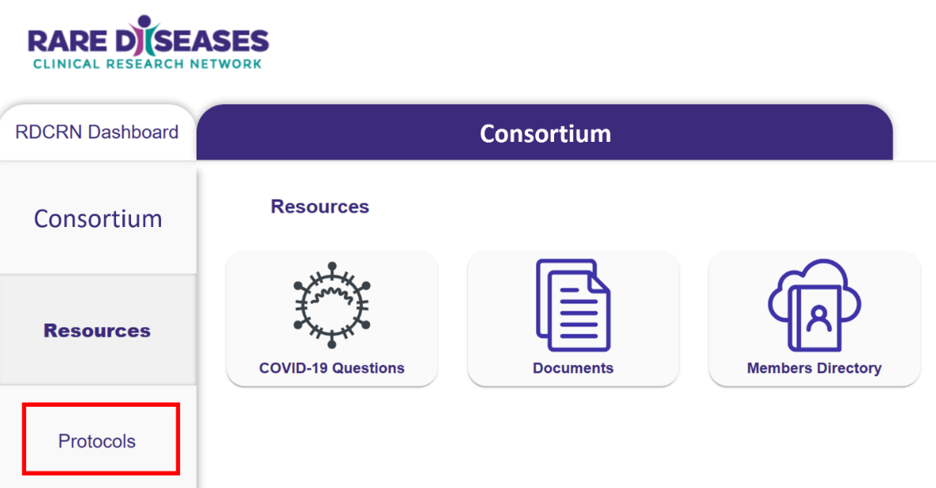

- From the Protocols page, click on the appropriate protocol number for access to training & the REDCap database.
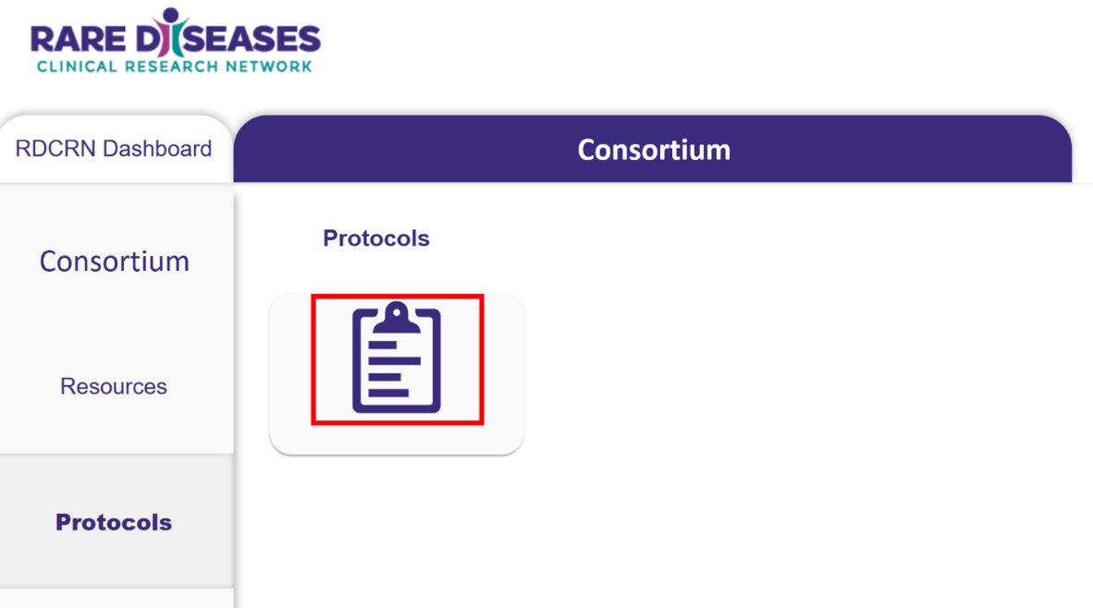

- Select the Database Training button to access the protocol training materials.
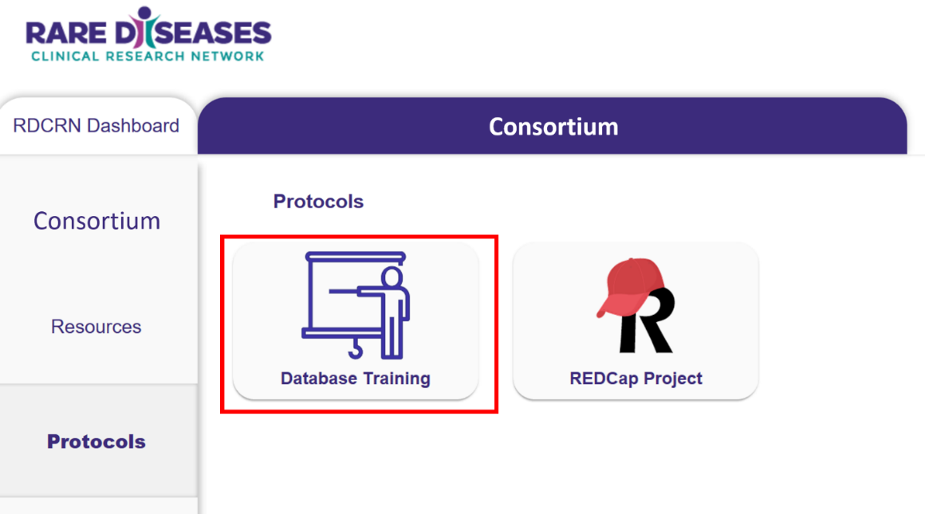

- Training courses may take one of several formats depending on the complexity of the training. They may be A) Single Activity Quiz B) Two Activity Quiz or C) Multiple Activity. Most of our courses are Single Activity Quizzes
  - Single Activity Courses display a training video without any required mouse clicks. A quiz captures your attestation that you’ve viewed the content. To successfully submit your quiz attempt, several button clicks are required.
    - Watch the video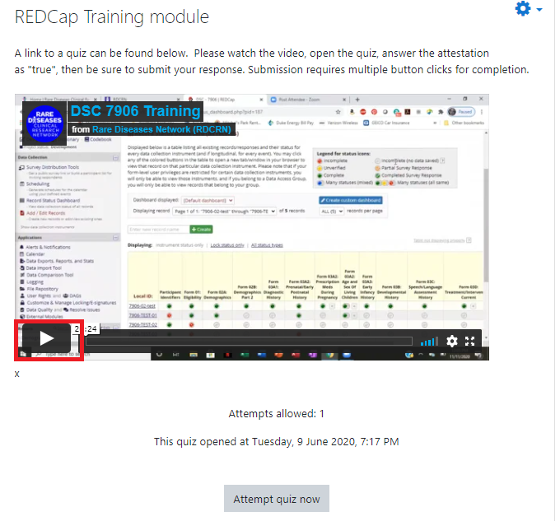
    - Start the quiz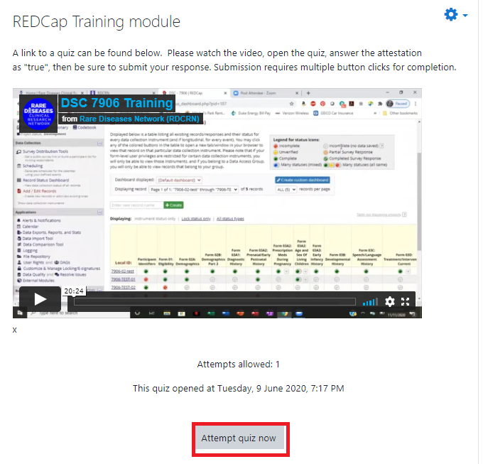

    - Select true for simple attestations, or else answer all relevant questions and Finish the Attempt

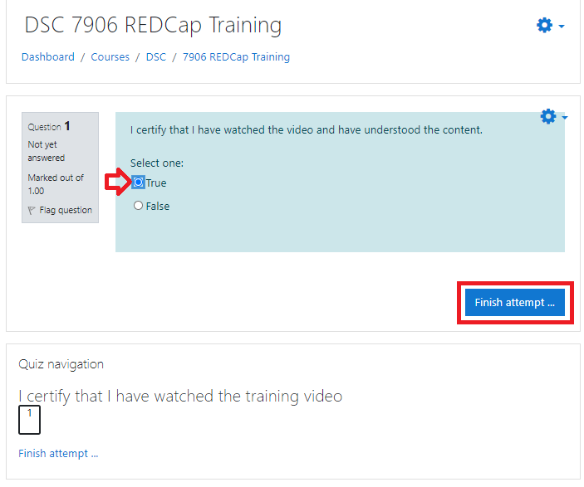
    - Submit all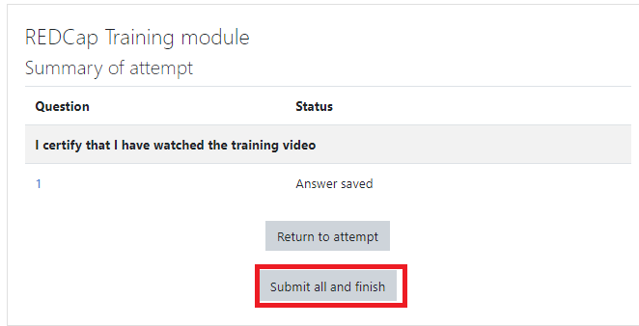
  - Two Activity Courses similarly consist of watching a video and attesting to watching it in a separate quiz, but those two requirements are found in separate assignments.
    - Click the Video link to watch the recorded database training and click on the REDCap Database Training Documentation to certify your training.
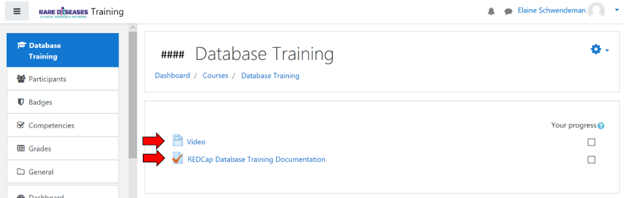

    - Complete the quiz to attest that you have viewed either the live training demonstration or the recording. 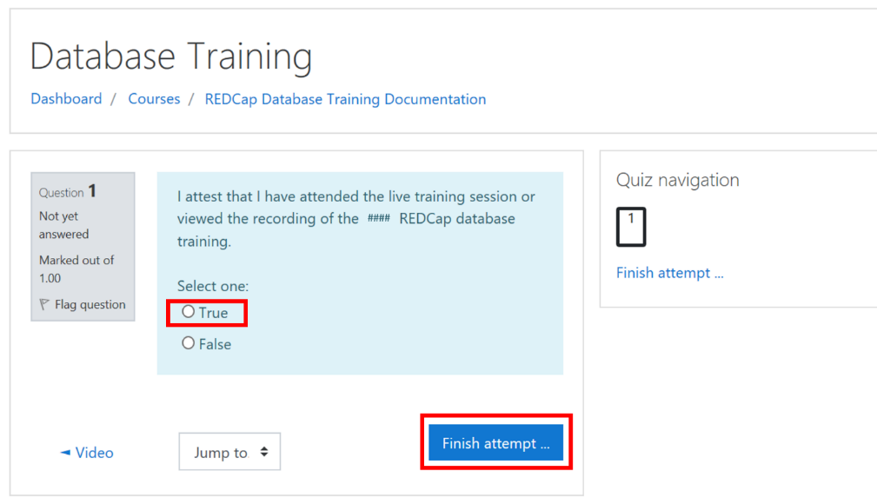
    - Finalize you submission by clicking submit all and finish
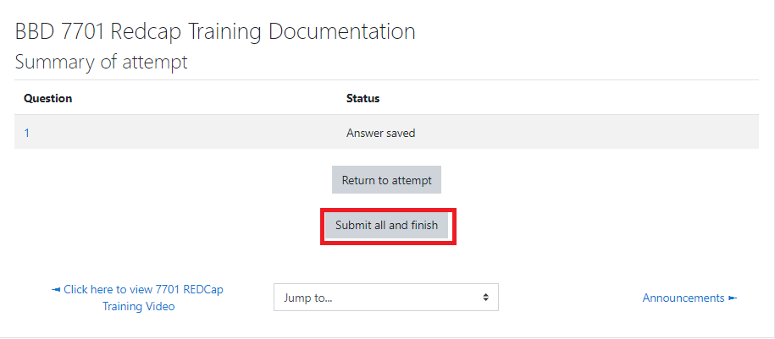
  - Multiple Activity Courses have several modules. Click and complete each section as above. Note however, that complex trainings such as these may include activities such as annual reviews that you may not need to complete right away. Please check with your Consortium’s project manager or other responsible staff

